**TIER IMPORT HC TESTING**

So I chose wine equipment kits for this test since all the products are visible in one page

Start with simple import

Result is like below

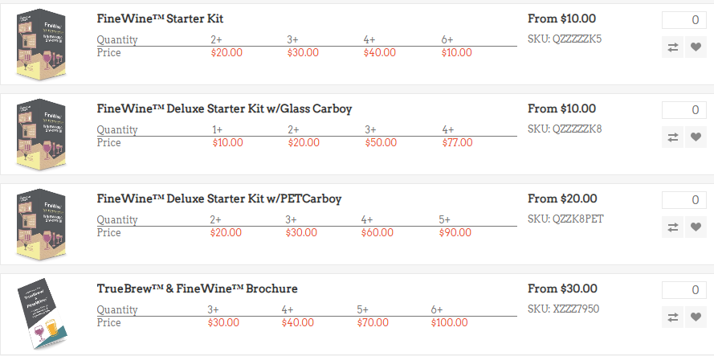

As you can see from above, there is an issue with QZZZZZK8 tier 4 price. The doc says it should be $80, but it says $77 there. So in the backend it shows this

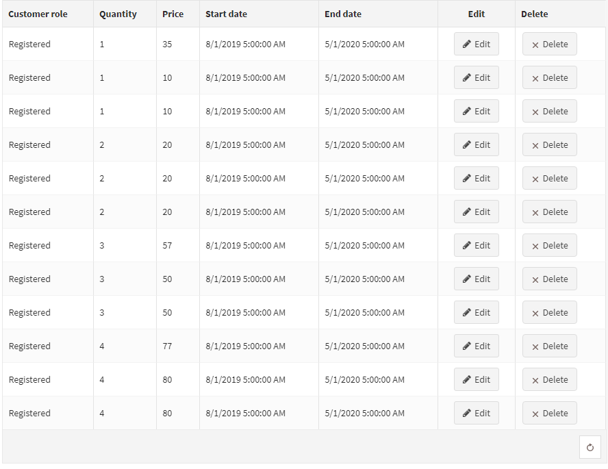

As you see, the qty 4 with price of 77 is above the price of 80 that we want while also having the same start and end date, so I guess it doesn’t seem to go to the latest one in the sequence?

However, changing the append from 1 to 0 (replace) seems to worked and cleared out all the excess tier pricing shown above

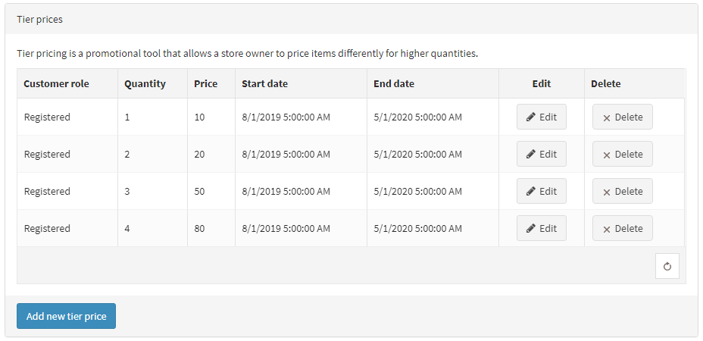

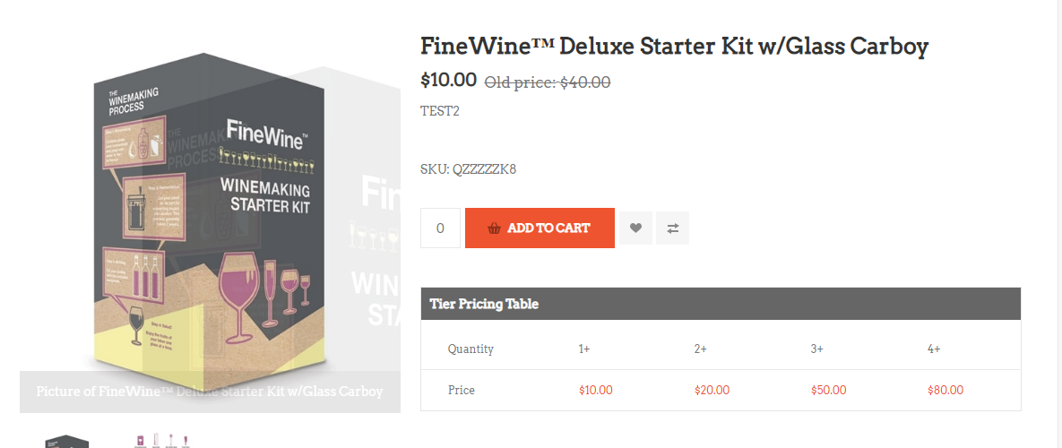

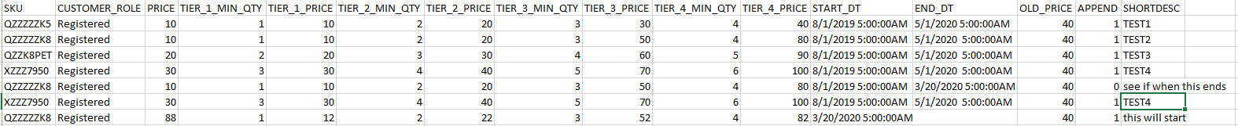In conclusion, append = 1 does append the price to the product pricing, however, it seems like things are being read consequentially, so the first/current active tier pricing is the one that will be displayed. Maybe if the time period of the first one runs out, it will automatically goes down the list and activate the next available one is a possibility, so I set this up below and will see what happen tomorrow

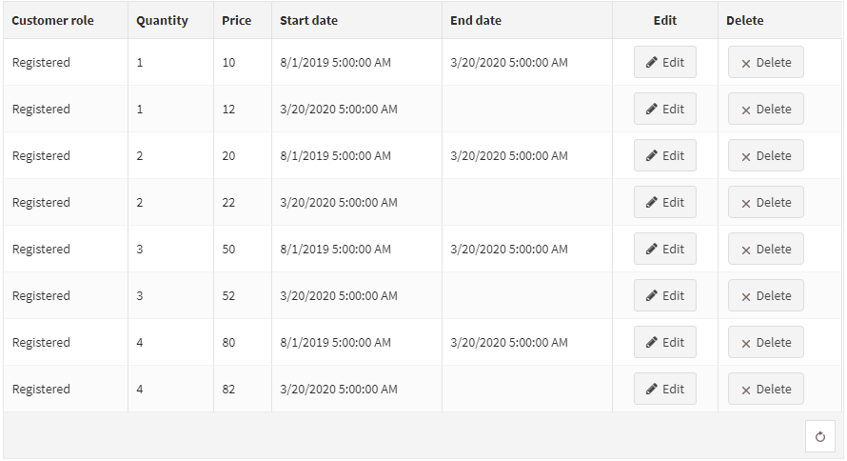

Lastly, I checked how appending works with items that are missing prices

So, this time I’m testing it on QZZZZZK5

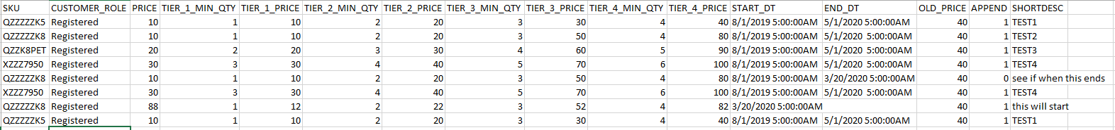Starting status

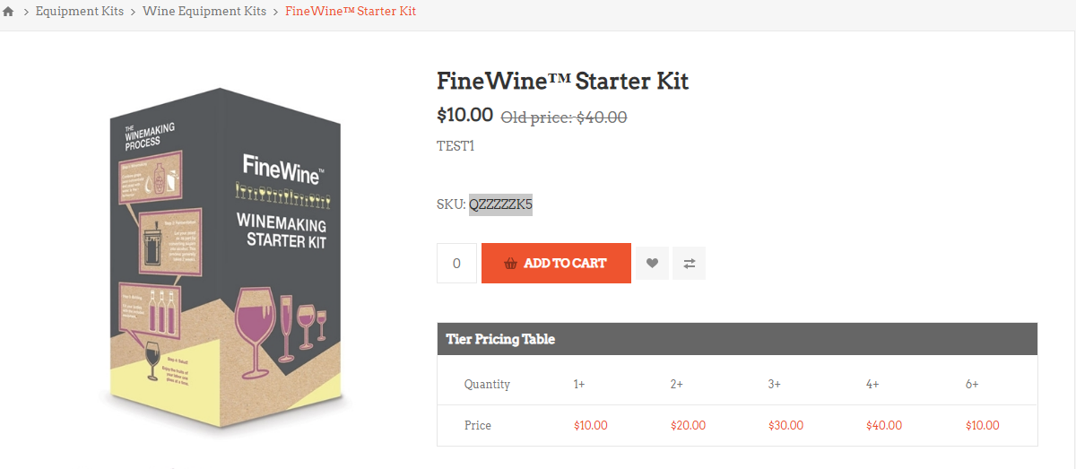

First, lets try changing price with append 1. Top: before, bottom after

Result: price changed

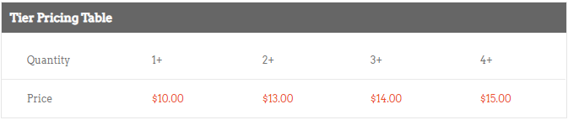

Next, I try removing some of the price with append set as 1

Result: price got removed

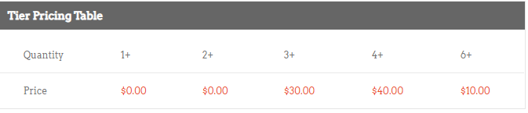

Next, I try to bring back tier 1 and 2 price without inserting tier 3 and 4 price

Result: all 4 prices are now set to zero. The tier 1 and tier 2 pricing doesn’t return

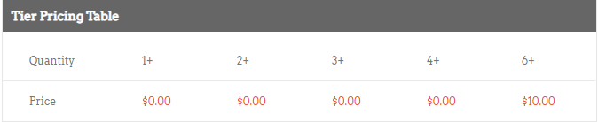

So we see here, append = 1 doesn’t seem to actually work at appending into missing stuff. Tier 1 and tier 2 prices is supposed to be set to $10 and $20 by way of append

Maybe it doesn’t like it when there are empty cells? Let’s try appending all 4 prices at once (append set as 1)

Result: nope. The prices still don’t return

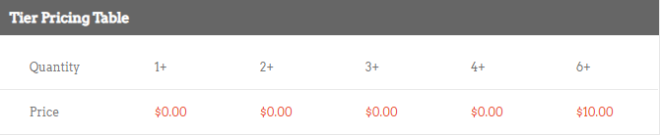

The only thing left to try is set append to 0 which will replace everything

Result: prices are back!!

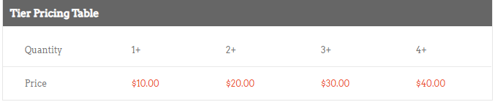

So, in conclusion. Append=1 is very finicky. Using it does seem to insert the entry into the product tier pricing, but doesn’t overwrite current one if their schedule clashed. I’m currently checking if when a tier pricing period ends, it will go down the list and find the next one.

For pricing appending, as shown above, append =1 only works when there is already an existing price it can overwrite, if the listing had any empty slot, only append = 0 can bring it back. Append = 0 is replace so basically, its like making new entry so you’d need to put in all the prices, not the ones you just want to change.